Week Commencing  9th November 2026   |  |  |  |  | 
Main dish | Spaghetti  &  Meatballs | Sausage  & Mash | Pork & Stuffing  Pie | Meat Curry | Battered  Fish Fillet
Vegetarian  Main dish | Spaghetti  & Quorn  Meatballs | Quorn Sausage  & Mash | Quorn Mince  Pie | Sweet Potato  Curry | Quorn Sausage  & Mash
Accompaniments | Garlic Bread  Seasonal Veg | Beans | Yorkshire Pudding  Roast Potato  Seasonal Veg | Naan Bread  Seasonal Veg | Chips  Mushy Peas  Beans
Desserts | Chocolate  Brownie | Marble Sponge  & Custard | Chocolate  Concrete  Cookie | Jam & Coconut  Sponge &  Custard | Carrot  Cake
Fresh fruit  or yoghurt | 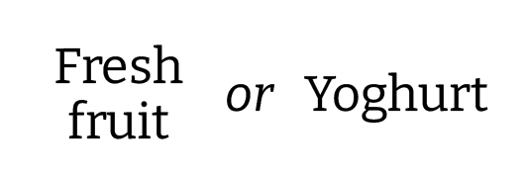
KS2 Option Only  Jacket potato  and sandwich selection | Pasta Pots  Jacket Potato | Pasta Pots  Panini | Pasta Pots  Jacket Potato | Pasta Pots  Panini | Pasta Pots  Jacket Potato

