Ho
Week Commencing  5th October 2026   |  |  |  |  | 
Main dish | Arrabiatta  Pasta  Garlic Bread | Chicken Burger  Wedges | Sliced Roast Pork  Roast Potato  Yorkshire Pudding | Chilli & Rice  Garlic Bread | Fish Fingers  Chips
Vegetarian  Main dish | Arrabiatta  Pasta  Garlic Bread | Southern Fried  Quorn Burger  Wedges | Quorn Sausage  Roast Potato  Yorkshire Pudding | Veggie Chilli  Rice  Garlic Bread | Quorn Dippers  Chips
Accompaniments | Sweet corn  Peas | Spaghetti Hoops | Broccoli  Carrots | Green beans  Sweet corn | Beans  Mushy Peas
Desserts | Strawberry  Whip | Chocolate  Brownie | Ice Cream  Sponge | Hob Nobby  Oatie Cookie | Chocolate  Crunch
Fresh fruit  or yoghurt | 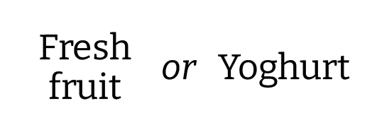
Jacket potato  Pasta Pots  Paninis | Jacket Potato  Pasta Pots | Paninis  Pasta Pots | Jacket Potato  Pasta Pots | Paninis  Pasta Pots | Jacket Potato  Pasta Pots

