Week Commencing  21st September 2026   |  |  |  |  | 
Main dish | Margarita Pizza  Wedges | Chicken Curry  Rice & Naan | Pork Sausage  Roast Potato  Yorkshire Pudding | Pepperoni  Tomato & Cheese  Pasta  Garlic Bread | Battered Fish  Fillet  & Chips
Vegetarian  Main dish | Margarita Pizza  Wedges | Sweet Potato Curry  Rice & Naan | Quorn Sausage  Roast Potato  Yorkshire Pudding | Arrabiata Pasta  Garlic Bread | Breaded Vegetable  Fingers  & Chips
Accompaniments | Spaghetti Loops | Green Beans  &  Peas | Broccoli  &  Carrots | Sweetcorn  & Peas | Beans  Or  Mushy Peas
Desserts | Chocolate  Brownie | Ginger  Cookie | Cheese  & Biscuits | Jelly  & Fruit | Carrot  Cake
Fresh fruit  or yoghurt | 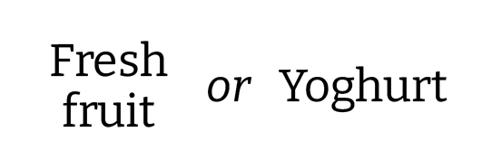
Jacket potato  Pasta and Panini | Jacket Potato  Pasta Pots | Paninis  Pasta Pots | Jacket Potato  Pasta Pots | Paninis  Pasta Pots | Jacket Potato  Pasta Pots

