We will read, write, order and compare numbers to at least 1,000,000 and know the value of each digit.
Also count forwards and backwards in tens, hundreds, thousands, tens of thousands and hundreds of thousands.
Rounding numbers.
Read Roman numerals to 1,000 and recognise a year written in Roman numerals.
We will also be checking times tables and the Power of 10.
Novel Study
In Year 5, we will be beginning the Autumn term with the magic and mystery of Harry Potter and the Philosopher’s Stone – the first of J.K Rowling’s Harry Potter series.

The children will develop their writing skills so that the purpose of their writing is clear and their sentences crafted carefully with superb vocabulary to keep the reader interested. We will look at describing a mysterious and curious character and their setting. Our inspiration will be taken from the text as well as our visit to the Harry Potter Studios!!


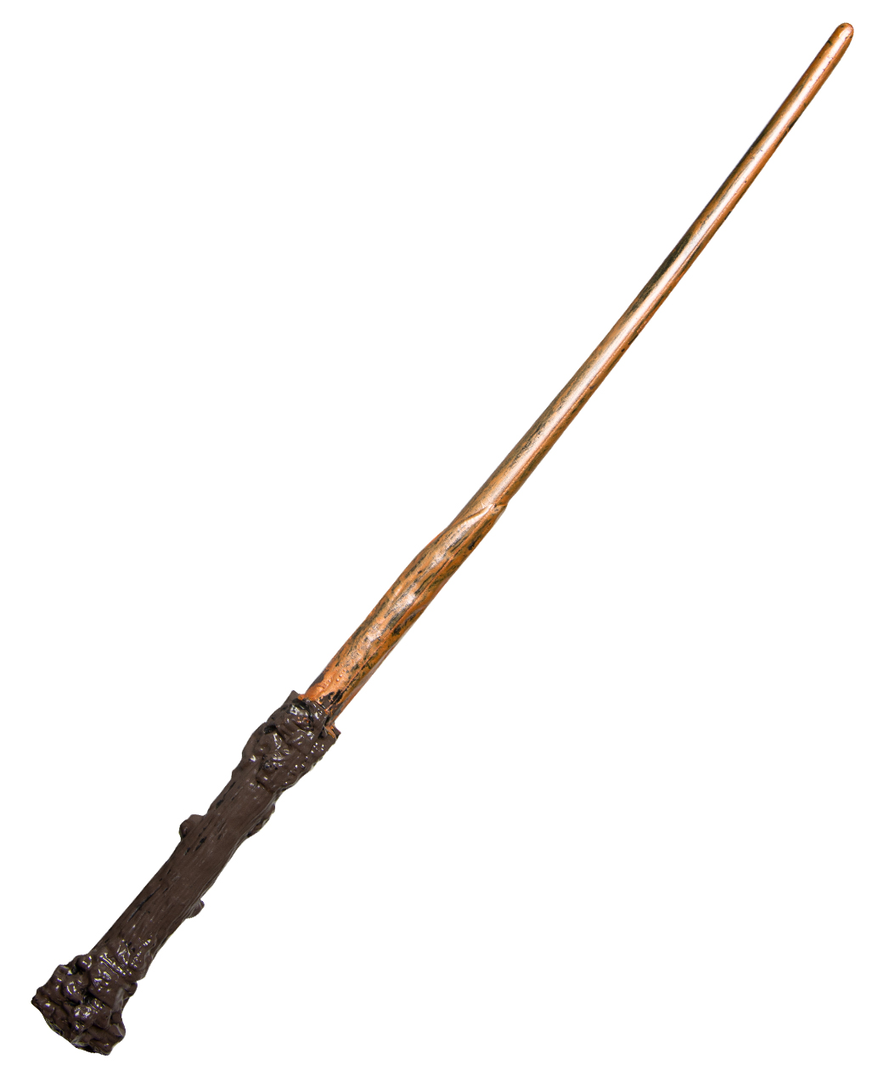
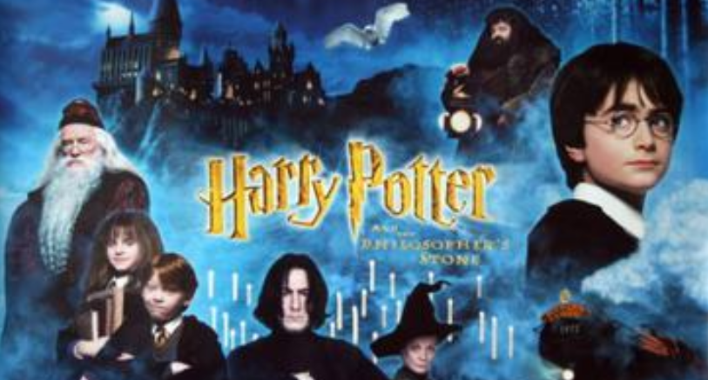
Foundation Subjects
Mathematics
Year 5 Autumn term 2025
Science As part of our ‘As if by magic’ theme, we want to find out whether we can make things disappear in science. Can we make things reappear? Together we will experiment with mixing materials that dissolve and find out if we can separate them. We will also be looking for changes to see whether a permanent change has taken place. It’s going to be like a potions lesson but using real science!
Art Can we experiment with paint to create an illustration of the impressive Hogwarts School Of Magic and Wizardry? We will be looking at different paints, techniques and mark making, did you know you can sprinkle salt onto paint to create a desired effect? We can’t wait to see the results!
Music The music in Harry Potter is famously magical. We will listen carefully to different pieces of music and give our opinions before having a go at creating our own piece of atmospheric music using different instruments and technology.

RE

French
In RE we start our learning by looking at symbolism and commitment in Sikhism. We learn about the 5Ks and what they represent. By the end of the unit we will confidently be able to discuss how Sikh’s live and their beliefs.

In French we will follow the text of familiar rhymes and songs identifying the meaning of the words. We will listen and respond, play word games and start to converse in a simple manner. In this first term our main topic will be about Healthy Eating – Bonne Sante.

Physical Education
Please bring your PE kit into school and leave it in your locker for the week. We will be getting changed
in school, This is good practise for when we reach Secondary School. We will focus on rugby and dance.
Y5 PE day is MONDAY AND FRIDAY
Please remember for PE kit you will need: trainers or pumps, a plain white t shirt, black / navy shorts. If the weather is cold, you are able to wear black navy tracksuit bottoms and a black / navy jumper / tracksuit top.
SWANS ARE STARTING SWIMMING FIRST.

Reading:
Please read every night to an adult: this can be your school reading book, a book you have accessed on Bug Club or your own from home. Please get an adult to comment and sign your planner. This will be checked every week.

Spelling
Pupils will have weekly spellings to learn and can log onto SPELLING FRAME to help them do this. We will have a weekly spelling test to check. There are many fun ways to learn your spellings – ask your teacher for some ideas.

Home Learning

