Week Commencing  8th June 2026   |  |  |  |  | 
Main dish | Jacket Potato  Cheese | All day breakfast | Sliced Turkey  Yorkshire Pudding  Roast Potato | Sausage, Cheese  & Tomato  Pasta  Garlic Bread | Fish Cake  & Chips
Vegetarian  Main dish | Jacket Potato  Cheese | Veggie all day  breakfast | Quorn fillet  Yorkshire Pudding  Roast Potato | Cheese & Tomato  Pasta  Garlic Bread | Quorn  Nuggets & Chips
Accompaniments | Beans | Spaghetti  Hoops | Broccoli  &  Carrots | Sweetcorn  Green beans | Beans  &  Mushy Peas
Desserts | Raspberry  Whip | Marble Cake | Ice Cream | Chocolate  Crunch | Jelly &  Fruit
Fresh fruit  or yoghurt | 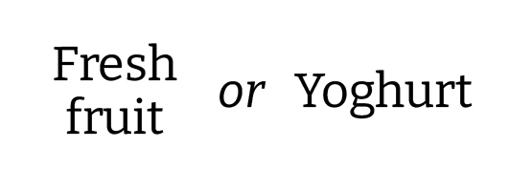
Jacket potato  Panini  Pasta Pots | Jacket Potato  Pasta Pots | Paninis  Pasta Pots | Jacket Potato  Pasta Pots | Paninis  Pasta Pots | Jacket Potato  Pasta Pots

