We will be beginning the summer term’s Novel Study by looking at The Lighthouse Keeper’s Lunch

The children will write a list of instructions to make a puppet, write character descriptions based on the main character, write an alternative ending to the story, as well as reinforce key punctuation such as full stops and capital letters and learn where and how to use question marks and exclamation marks.

Children will continue to access Read Write Inc lessons to get a sound understanding of letters and sounds.
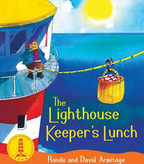
Mathematics
Novel Study
- Number and place Value up to 100
- Telling the time
- Shape
- Money (coins and notes)
- Position and direction
We will continue to practise number formation, reading and writing numbers in words as well as numerals.
Please visit the Numbots website (log in details in reading planner) for extra practise.
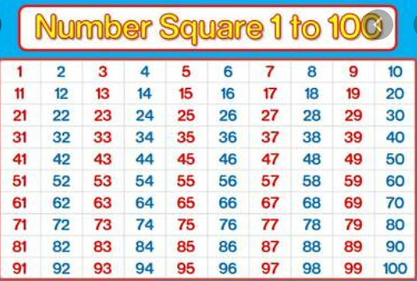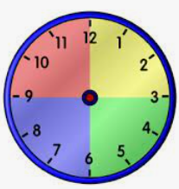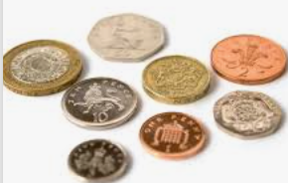

Global Citizenship and RE
Foundation Subjects
Year 1 Summer term 2026
- Children will explore and consider the questions: How do stories help Hindus live their life? and How and why do some people pray? We will explore this in the context of various religions.
- The theme for PSHE is “Dare to be you”. We will explore different values and wider world views.
Science What are my senses and why are they useful?
History What was the seaside like in the past? Children will explore what the seaside looked like and how things have changed.
Art Can I interpret an object through drawing in the style of Alfred Wallis? Children will draw shells inspired by the artist, Alfred Wallis.
Design and Technology Can I design a puppet in the style of a Punch and Judy show? Children will design and make their chosen puppet using a range of materials.
Music Exploring sound, children will create a soundscape using tuned and untuned percussion instruments,
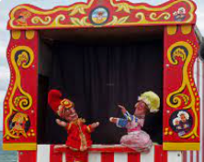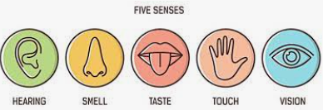

Physical Education

Children can bring their PE kit into school and leave it on their peg. They can also come to school dressed in their PE kit on their PE days which they will stay in all day.
Starlings PE days are TUESDAY and FRIDAY.
Nightingales PE days are TUESDAY and FRIDAY.

Please remember for PE kit you will need:
- trainers or pumps
- a plain white t shirt
- black / navy shorts. If the weather is cold, you are able to wear black navy tracksuit bottoms and a black / navy jumper / tracksuit top.
- Water bottle & sun hat for warm weather
- Please remember to put any suncream on before coming to school.

Home Learning
Reading: Please read every night to an adult this can be your school reading book, a book you have accessed on Bug Club or your Read Write Inc book. Please get an adult to comment and sign your planner.
Weekly reads will be counted on a Monday (Nightingales) and Wednesday (Starlings) where anyone who reads 5 times or more will be given a treat. Reading for Pleasure books will also be changed on these days each week. These books are given to be shared with an adult.
Maths: Children can visit the Numbots site (log-in information in planner) to play interactive fun maths activities to earn certificates and to develop their understanding, recall and fluency of addition and subtraction facts.

