Week commencing  23rd February 2026   |  |  |  |  | 
Main dish | Pepperoni Pizza  Wedges | Chicken Curry  Rice & Naan | Sliced Turkey  Roast Potato  Yorkshire Pudding | Mince Pork  Cobbler  Mash Potato | Battered Fish  Fillet  & Chips
Vegetarian  Main dish | Margarita Pizza  Wedges | Sweet Potato Curry  Rice & Naan | Quorn Fillet  Roast Potato  Yorkshire Pudding | Veggie Curry &  Naan Bread | Breaded Vegetable  Fingers  & Chips
Accompaniments | Spaghetti Loops | Green Beans  &  Peas | Broccoli  &  Carrots | Sweetcorn  & Peas | Beans  Or  Mushy Peas
Desserts | Chocolate  Brownie & Custard | Cookie | Cheese  & Biscuits | Syrup Sponge  & Custard | Chocolate  Crunch & Custard
Fresh fruit  or yoghurt | 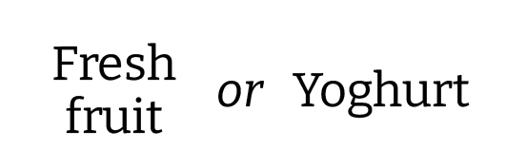
Jacket potato  and sandwich selection | 

