Understanding Different Types of Knowledge in History
Hayfield LANE pRIMARY sCHOOL
hISTORY

Understanding Different Types of Knowledge in History

Substantive Knowledge
This is factual knowledge of the past: key events, place and people. It includes four types of knowledge: 'Generative Knowledge’, ‘Substantive Concepts’, ‘Chronological Knowledge’ and ‘Fingertip Knowledge’ (Must Know Facts)
Generative Knowledge is the essential, underpinning, in-depth knowledge of a topic or time period that supports further historical learning and thus supports pupils to generate more knowledge. Generative knowledge can be categorised into 'substantive concepts' (abstract concepts such as monarchy, trade, or empire) and chronological knowledge (knowledge relating to broader developments and the features of historical periods).
Substantive Concepts are concepts concerned with the subject matter of history, such as civilisation, monarchy, empire, invasion, war, parliament, trade and religion. They are embedded throughout the curriculum so that each one is planned to be encountered multiple times throughout the curriculum. Substantive concepts are best understood with repeated encounters in specific, meaningful contexts, rather than being taught in an abstract way. Substantive concepts are classed as generative knowledge because they support the learning of new material. For example, understanding the concept of civilisation from an earlier topic supports understanding of the next topic which involves civilisation.
Chronological Knowledge is also generative knowledge. This is the specific knowledge of the broad characteristics of historical periods and supports pupils to build coherent schema for particular topics (hence the importance of a timeline)
Fingertip Knowledge is the knowledge of the key facts and dates which pupils need in their minds, or at their fingertips, whilst undertaking historical enquiries, without which they would be incapable of constructing answers. Without essential fingertip knowledge, working memory is overloaded when undertaking enquiries, and it is thus useful to have this fingertip knowledge in Must Know Facts. Fingertip knowledge must be taught and pupils must retain it during their enquiry. However, gaining this type of knowledge is not the ultimate long term aim of the primary classroom, and it may not be needed beyond the current topic
Disciplinary Knowledge and Historical Enquiry Disciplinary knowledge is knowledge about how historians investigate the past, and how they construct historical claims, arguments and accounts - it is the knowledge of how to undertake historical enquiry. Pupils learn disciplinary knowledge within relevant historical contexts through application to substantive knowledge. Our units of learning are framed around central big questions which focus a unit of work on elements of this disciplinary knowledge. This knowledge of historical enquiry frames what pupils learn about the past, supporting them to consider the status of historical claims. It enables them to place their historical knowledge in a broad context. It helps pupils to understand the different version of the past can be constructed, and that historical narrative is partially dependent upon viewpoint. Disciplinary knowledge is concerned with developing historical rational and critical thinking within enquiry, and can be categorised into seven disciplinary concepts that are systematically developed in our history curriculum:

Chronological Understanding - being able to employ dates and terms to describe the past, and realise that the past can be divided into periods.
Historical enquiry using sources - asking questions, using sources and evidence to construct and challenge the past.
Historical enquiry communicating ideas – Communicating and organising finds with a systematic approach.
Cause and consequence - selecting and combining information that might be deemed a cause and shaping it into a coherent causal explanation and understanding the relationship between an event and other future events.
Continuity and change - analysing the pace, nature and extent of change.
Similarities and differences - analysing the extent and type of difference between people, groups, experiences or places in the same historical period.
Historical significance - understanding how and why historical events, trends and individuals are thought of as being important.
Historical interpretations - understanding how and why different accounts of the past are constructed.
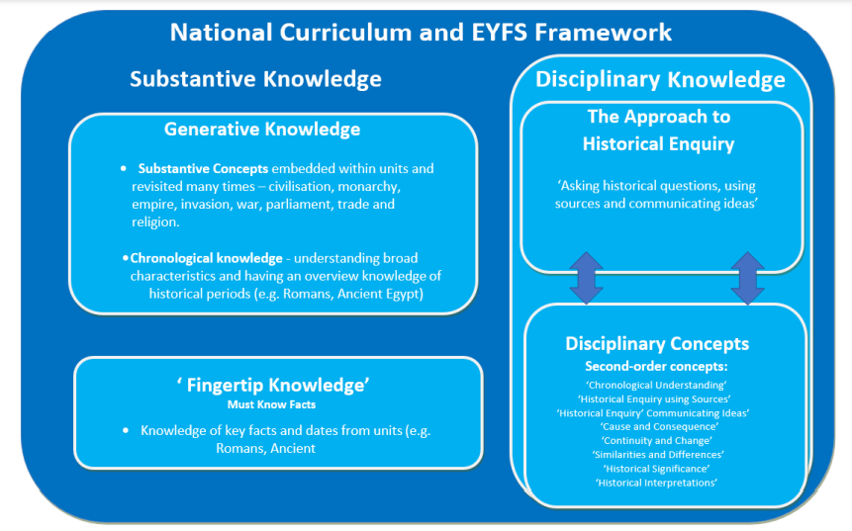
Development of historical enquiry and Second order components
Similarities and differences
This concept looks at the similarities and differences between people, groups, places or experiences in the same historical period and between different historical periods. The children then use these comparisons to help them understand the way people lived in the past.
Continuity and Change
This concept looks at how life during a period of history changed for different groups of people and in what ways it remained the same. What changed during a period of history? How did a period of history change? What were the reasons behind a change in a period of history? How did that change affect the people within that period? What remained the same and why?
Significance
This concept looks at people and events that were significant during a particular period and still have an impact today. It could be an individual who: Did something important that changed people’s lives at the time or after, had a lasting impact on their country or the world. Changed events at the time they lived.

Causes and Consequences This concept looks at the causes of events that have happened in history and then the consequences following these events. What caused this event? What were the consequences of this event? Did these events cause short or long-term consequences?

FURTHER INFORMATION
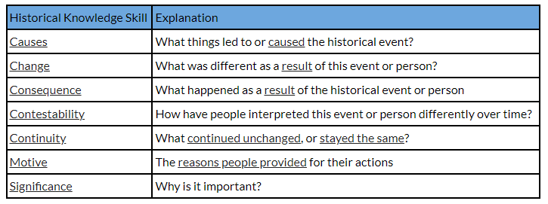
CAUSES
As you study historical events, you will discover that things do not simply ‘happen’ without reason.

Historical events are caused by things that occurred before them.

Also, historical events create changes that have consequences long after the event is over.

Cause and consequence is a relationship in history between an event, a condition, or a decision (the cause) and the events or results that follow it (the consequences).

Understanding cause and consequence is a key aspect of historical analysis and helps historians to understand how and why things happened in the past.

Every historical event occurred because of a series of events that happened beforehand.

Things that directly lead to another event are called ‘Causes’. Some causes occurred immediately before the event began, while others existed for several years before they caused the event.
- Causes that occurred only a few hours, days or weeks before the event are called 'Short Term Causes'
- Causes that existed for years, decades or centuries before the event are called 'Long Term Causes'
Example questions for assessing Causes:
- Why did the event under examination occur?
- What earlier events were central to the occurrence of the event under examination?
- What motivated the people who were involved in this event?
- What were the economic, political, military or social reasons that led to this event?
More information and video
https://www.historyskills.com/historical-knowledge/causes-and-consequences/

CHANGE AND CONTINUITY
CHANGE
In order to study change and continuity, historians study different types of events through time and group these events based upon topics or themes.

Breaking historical events up based upon categories makes it easier for people to identify changes and study the effects on people over time.

Some general categories of events include:
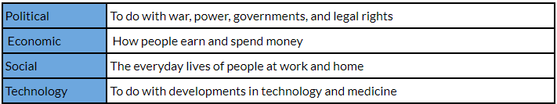
‘Change’ refers to something that is obviously different from what occurred previously.

Change refers to the alterations or transformations that occur in societies, cultures, political systems, or other aspects of the human experience over time.

Change can result from a variety of factors, including technological advancements, natural disasters, wars, social movements, and economic developments.
It can be both positive and negative, and it can impact individuals and communities in different ways.
Change in history usually occurs over a long period of time and it is often hard to pin-point an exact moment of change.

More information / video to explore and explain
https://www.historyskills.com/historical-knowledge/change-and-continuity/

CONTINUITY
Not all things change over time, some things remain the same across long periods in time, sometimes lasting into the modern world.

‘Continuity’ refers to things that stay the same, relatively unchanged, over time.

This can include long-standing traditions, cultural values, or political systems that endure despite changes that may occur in other areas.

Continuity provides a sense of stability and a connection to the past, and it helps to shape the development of societies and cultures over time.
As historians, we need to study what things have changed or continued over time and try to explain the reasons for these.

Example questions for assessing Change and Continuity:
- What kind of historical development are you focusing on (e.g., religious, political, economic, cultural, etc.)?
- What was the situation like before this occurred?
- What was clearly different after this occurred?
- What were the direct causes of the changes?
- What were the reasons that some things remained the same?

HISTORICAL SIGNIFICANCE
Historical significance is a decision that modern people make about what is important from our past. In assigning historical significance, we can choose specific events, people, locations and ideas as being particularly important to us.
Since significance is a decision that we make, it means that different people can decide that different things are significant, or that they can disagree about the reasons a particular person, event, place or idea is important.
Therefore, significance is not the same to everyone, or at all times in history. What we consider to be important can change. As a result, some events which were considered significant a century ago may not be important to us now. Alternatively, we may consider something historically significant today that no-one cared about a hundred years ago.

Further information and video:
https://www.historyskills.com/historical-knowledge/significance/

