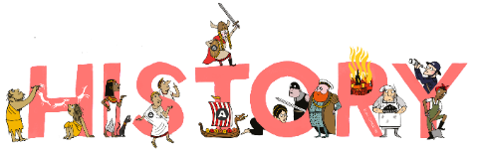
 | Autumn Term | Spring Term | Summer Term
Year 1 | Once upon a Time - Mr Straw’s House  Changes within living memory  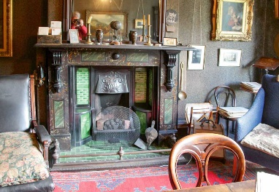  Legacy | Sensational Safari – Wright Brothers and Amy Johnson with a link to aviation in the local area  Events beyond living memory that are significant nationally or globally  The lives of significant individuals in the past who have contributed to national or international achievements  Significant historical events, people and places in their own locality  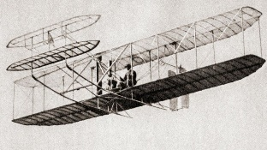  Aviation | Oh I do Like to be Beside the Seaside!  Changes within living memory  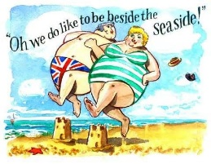  Legacy
Year 2 | Guy Fawkes – Bonfire Night  Events beyond living memories that are significant nationally or globally  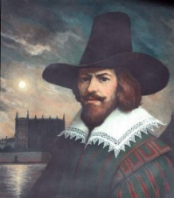  Leadership and Democracy  Belief Systems |  | The Tear Thief  The lives of significant individuals in the past who have contributed to national and international achievements. Some should be used to compare aspects of life in different periods    Aviation
Year 3 |  | Stig of the Dump  Changes in Britain from the Stone Age to the Iron Age  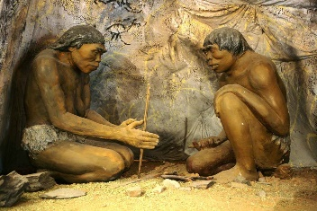  Legacy | Roman Invasion  The Roman Empire and its impact on Britain  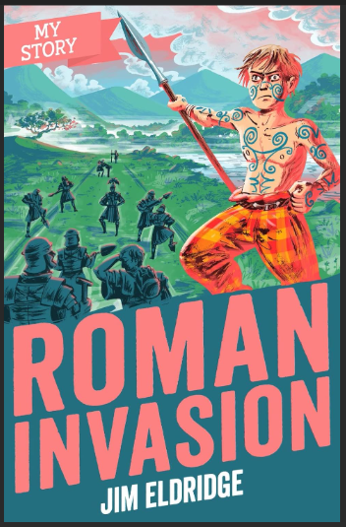  Conflict  Leadership and Democracy  Legacy
Year 4 |  | Secrets of a Sun King-Ancient Egyptians  Achievements of the earliest civilizations - an overview of where and when the first civilisations appeared with a depth study of one  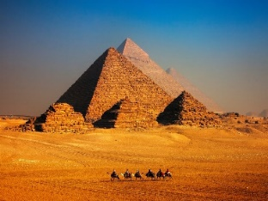  Belief Systems  Leadership and Democracy  Legacy | Early Islamic Civilisation  A non-European society that provides contrast with British history: Early Islamic Civilisation, including a study of Baghdad  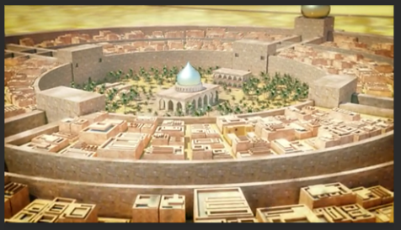  Belief Systems  Leadership and Democracy  Legacy
Year 5 |  | Why should we thank the Ancient Greeks?  A study of Greek life and achievement and their influence on the Western World  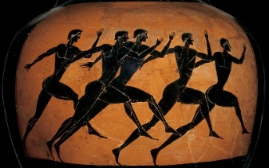  Belief Systems  Leadership and Democracy  Legacy | World War II with a focus on a significant turning point: The Battle of Britain and its links to the local area  Link to aviation theme from Ks1  A study of an aspect or theme in British history that extends pupils' chronological knowledge beyond 1066  A local history study  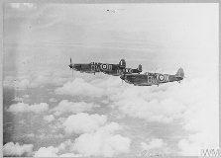  Aviation  Conflict
Year 6 |  |  | Anglo Saxon Boy versus Viking Boy  Britain's settlement by Anglo-Saxons and Scots  Viking and Anglo-Saxon struggle for the Kingdom of England to the time of Edward the Confessor  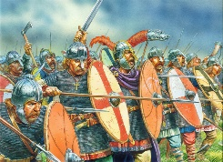  Leadership and Democracy  Conflict

Theme Overview
 | Aviation | Conflict | Leadership and Democracy | Belief Systems | Legacy
Year 1
Year 2
Year 3
Year 4
Year 5
Year 6

