2025/26

 | Autumn Term |  | Spring Term |  | Summer Term
 | Autumn 1 | Autumn 2 | Spring 1 | Spring 2 | Summer 1 | Summer 2
Year 1 | Once Upon a Time- Houses and Homes.  Construction- Making a home for the 3 little pigs.  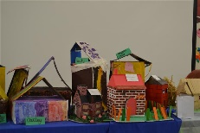 |  |  |  | Oh I do like to be beside the seaside!  Textiles- Punch and Judy puppets.  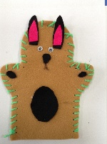
Year 1 | Modern house designers- Avant, Taylor Wimpey etc.  Careers link- Builder, architect. Anything from the building trade |  |  |  | Traditional design.  Fred Tickner was one of the great makers of Punch and Judy figures whose style influenced many later makers.  Career link- Theatre/film prop/costume design?
Year 2 | Pop up mechanisms- Create a moving picture using levers and sliders. (moving firework pictures/pop up image)  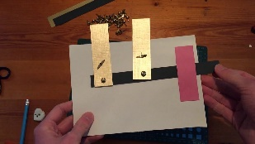 |  | Where does food come from?- Charlie and the Chocolate Factory  Cooking and Nutrition- Design and make a Healthy Snack  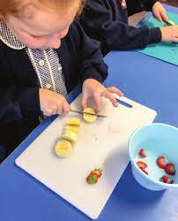
Year 2 |  |  | Modern design  Companies such as: Naked, Innocent etc.  fruit snacks  Careers link- Food technologist, dietician, chef
Year 3 |  |  | Textiles  Design and make an Iron Age Tunic  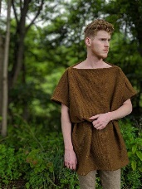 |  | Construction and use of materials & Mechanisms  Design and make a catapult with a lever . (Linked to Romans)  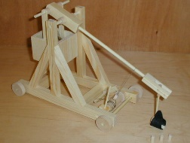
Year 3 |  |  | Careers link- Fashion designer |  | Traditional design  The Romans as innovative designers- legacy  Careers link- Military, modern warfare
Year 4 |  |  | Construction and Mechanical Components  Making modern Shadufs using gears and pulleys  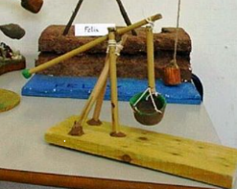 |  | Electrical Components and mechanical  Design and make a robot head  - Electrical, pneumatics, hydraulics.  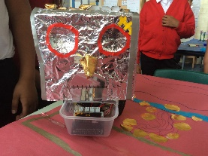
Year 4 |  |  | Traditional design  Ancient Egyptians as architects- legacy. Look at modern day systems via Yorkshire Water- dams/reservoirs etc  Careers link- Civil engineer, hydraulic engineering, water management. |  | Modern design  French military surgeon Ambroise Paré drew the first detailed design of a spring-loaded prosthetic hand.  Careers link- Medical engineering.
Year 5 |  |  | WW2- Evacuees  Cooking and Nutrition-  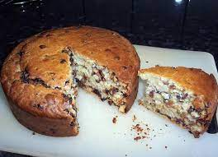 |  | Textiles – WW2 soft toy  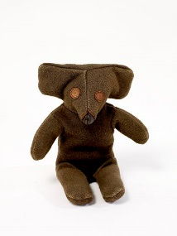
Year 5 |  |  | Traditional design  Dan Lepard specialises in rationing recipes as per WW2  Careers link- Food technologist, chef |  | Traditional design  The first stuffed felt elephant originally sold as a pincushion, was created by Margarete Steiff, founder of the German Steiff company in 1880. Steiff used newly developed technology for manufacturing upholstery to make its stuffed toys.  Careers link- sustainable fashion.
Year 6 | Making a game using electrical and mechanical components. (To include electrical components and cams)  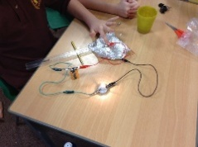 |  |  |  | Food Seasonality
Year 6 | Modern design.  John Spinello created the game “The Box that Sparked and Made Noise,” also known as “Operation” in 1962 at the University of Illinois as a sophomore in a class project  Careers link- Video game designers? Electrical engineering? |  |  |  | Links to agriculture- food supply industry.

