HAYFIELD LANE PRIMARY SCHOOL



SCHOOL IMPROVEMENT PLAN 2025/26
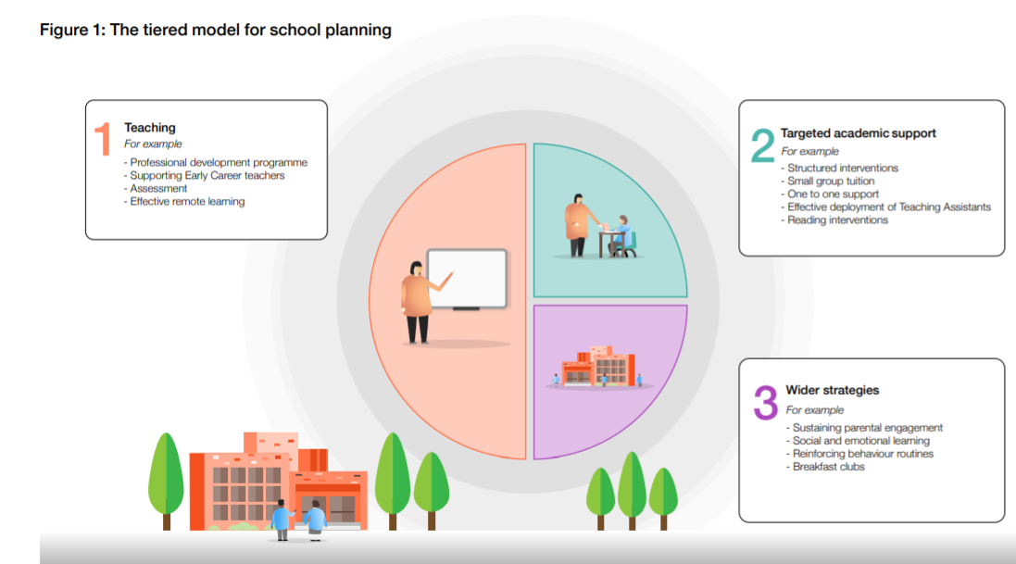

Hayfield Lane Primary School Recovery School Improvement Plan 2025/26
High quality teaching is proven to have the most impact on school improvement, hence the reason for being the prime element of the SIP. There is also extensive evidence supporting the impact of high quality 1:1 and small group tuition as a catch-up strategy (EEF). This academic year will continue to be based on EEF Improving Literacy and Maths documents, Securing Effective Professional Development cog document, Using Diagnostic Assessment To Address Learning Gaps document and High Quality Daily teaching using the 5 A DAY approach as specified in the EEF guide ‘Moving Forward Making a Difference’ guidance. It will also build on previous research base of Rosenshine’s Principles of Instruction and Tom Sherrington’s adaptation of this, Fiorella and Mayer’s Generative Learning , Sweller’s Cognity Load research, A Bedford and Unity Research School’s Quality Assurance of Curriculum documents and also links to the research base specified in TRUST BASED OBSERVATIONS by C Randall-drawing from effective reflective practice to develop rapid and sustained QFT . This is utilised as it is at the heart of EEF guidance documentation and draws together a significant, global research base. Critical thinking developments will also be enhanced by VARIATION THEORY research (Barton, Marton, Gu Ling Yuan)
INTENT
KEY PRIORITY 1 – Improve KS2 Reading test outcomes for vulnerable pupils so that they meet the national averages by developing pupil problem solving and generative connections within timed, test situations | KEY PRIORITY 2 – Improve KS2 Writing outcomes for vulnerable pupils so that they meet the national averages by developing pupil problem solving in reading and generative connections | KEY PRIORITY 3 – Subject Leaders are effectively driving 3 C deepened learning opportunities . Effective modelling of this in 100% classes
IMPLEMENTATION 1 | IMPLEMENTATION 2 | IMPLEMENTATION 3
- Vulnerable pupil cognition adjustments made in support plan documents  - Vulnerable pupil cognition adjustments made in provision mapping and PPD process  - Collaboration meetings developed to drive whole school improvements with phonics lead, early communication lead and reading and writing leads  - Embed flow chart approach for comprehension sessions  - Revised Reading Policy (Teaching and Learning and Curriculum)  - Altered classroom organisation/layout for neurodivergent readers by examining best practice  - Fluency sessions for vulnerable readers/poor attenders. Embed flow chart use in small group  - Development of EYFS Speech Therapy in-lesson provision  - Model use of reading thread development/comprehension task modelling via joint writing thought process CPD  - TBO format to use pre-meet discussion with staff  - Validate progress made via PEER REVIEW PROCESS  - PPD- provision mapping tight alignment to support plan targets  - Application tasks evident in all reading sessions to prepare for independent test questions  - Gap analysis content matches coverage weighting  - Training session for new governors/GMG changes  - Gain parent voice feedback on improvements  - Parent support areas on new website | - Writing policy adapted to meet content of Writing Framework  - Spelling scheme of work embedded across KS1  - Collaboration meetings developed to drive whole school improvements with phonics lead, early communication lead and reading and writing leads  - Relaunch of Martin Harvey Handwriting scheme  - Embed Hywel Roberts writing sessions-revisit planned opportunities  - Use of mini books for vulnerable learners  - Peer goal setting sessions (Rethinking Assessment trail 2025)  - Embed joint writing process across school CPD  - Revised Writing policy (Teaching and Learning and Curriculum)  - Altered classroom organisation/layout for neurodivergent writers-examining best practice  - Development of EYFS Speech Therapy in-lesson provision  - Validate progress made via PEER REVIEW PROCESS  - TBO format to use pre-meet discussion  - PPD- provision mapping tight alignment to support plan targets  - Immediate application tasks used in all writing sessions  - Training session for new governors/GMG changes  - Gap analysis content matches coverage weighting  - Develop brain gym exercises prior to handwriting sessions EYFS and KS1 to i8mprove motor control  - Gain parent voice feedback on improvements  - Parent support areas on new website | - Mentor new Subject Leaders new to role  - TBO format to use pre-meet discussion (revised format)  - Ensure effective delivery of new RE scheme of work  - Monitor impact of new RE scheme in relation to 3 C expectations  - Ensure effective delivery of new PSHE scheme of work  - Monitor impact of new PSHE scheme in relation to 3 C expectations  - Development of learning mentor-adult focusing on cognition adjustments (4 5 and 6)  - Development of peer learning mentors- emotional engagement. ( 3 and 4)  - Peer goal setting across topics (pupil trial in 4 5 and 6)  - Increased independent writing in learning opportunities (applying)  - Further staff developed as potential leaders in innovation projects. AI BIG EDUCATION  - Development of SKILLS HUB Days for deepened learning opportunities involving parents  - Gain parent voice feedback on improvements

