In Maths we will be learning:

-To count objects to 100 and write in numerals and words.
-To represent numbers to 100.
-To compare and orderobjects and numbers.
-To count in steps of 2,3,5 and 10 both forwards and backwards.
-To add and subtract numbers within 100.

Mathematics
Who was the main villain of the Gunpowder Plot?

This half term we will be learning about The Gunpowder Plot! We will be having a Gunpowder Plot Parent exhibition for Year 2 during the half term. We will be sending more information out about this soon!

The children will learn about Guy Fawkes and his plan to blow up the Houses of Parliament and decide who they think the main villain of the Gunpowder Plot was.

During this term we will focus on spelling phonetically, using capital letters, full stops, finger spaces and using conjunctions to join sentences.

Novel Study
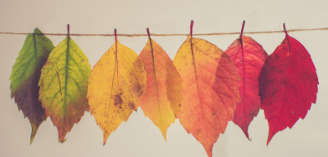 Autumn 2025
Year 2 Kingfishers and Mighty Ducks
Year 2 Autumn term 2020
Foundation Subjects

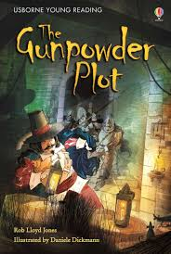
History & Geography
In history this term we will be learning:
-Key facts about the Gunpowder Plot
-How Guy Fawkes has impacted our lives.

In Geography we will be learning:
-The countries and capital cities in the United Kingdom.
-Draw maps
-Follow a route on a map using North, South, East and West.

Art
In Art we will be painting bonfire night pictures and learning to:
-Make links between Bonfire Night and Art
-Say how artists/craftmakers use colour, pattern and shape
- Mix paint to explore colours and create different shades of a colour

Computing
In Computing we will be learning to:
-Find and retrieve information from a website
-Use texts, pictures and animations to create content.
-Create, edit and format text
-Coding

Music Exploring sound, choosing instruments and listening to sounds all around us.
Global Citizenship & RE

How can we make good choices?
We will explore how people always face moral choices and study moral codes from Christianity, Judaism and Islam.

Science

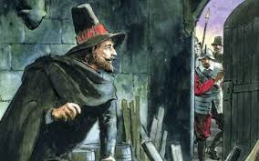
We will explore Living Things and their Habitats and learn how different habitats provide for the basic needs of plants and animals.

Home Learning
Reading:
Please read every night to an adult. This can be your school RWI book, Bug Club book (online or book) or your reading for pleasure book. Please get an adult to comment and sign your planner please.

Every WEDNESDAY we will count the number of reads for the week, change reading books and change pleasure for reading books. There will be a reading treat for those that have read 5+ times.

Numbots & Times Table Rockstars
Children will have access to Numbots and Times Table Rockstars. They are fun and challenging apps designed to help children master addition, subtraction, multiplication and division.

Physical Education
Please come to school DRESSED IN PE KIT on days when you have PE please. Children will not be getting changed in school, therefore you do not need school uniform on those days, thank you.
Mighty Ducks have PE on a Tuesday
Kingfishers have PE on a Wednesday.

Please remember for PE kit you will need:
- trainers or pumps, a plain white t shirt, black / navy shorts.
- If the weather is cold, you are able to wear black navy tracksuit bottoms and a black / navy jumper / tracksuit top.
- Please remember to bring a water bottle daily

