Sport Premium Overview
Hayfield Lane Primary School’s Vision Statement
“At our school we work together to provide a welcoming community for everyone. We aim to develop happy, motivated children within a secure , stimulating environment where everyone feels valued and strives to achieve their true potential”
At Hayfield Lane Primary School we believe PE & Sport plays an important role in making our vision statement a reality for every pupil, with the potential to change young people’s lives for the better.
Through PE & Sport our children learn to develop the important qualities of discipline, resilience, communication, team work, and ambition, leading to improved concentration, attitude, and academic achievement.
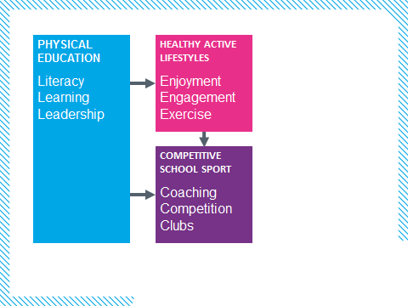
The Vision
We have welcomed the Government’s announcement in June 2013 to provide additional funding for 2 years to improve provision of physical education (PE) and sport in primary schools. We are committed to using this resource in developing high quality PE lessons , alongside greater opportunities for sporting competitions and clubs for all our young people.
What does the Sport Premium mean for my School?
‘Schools must spend the additional funding on improving their provision of PE and sport, but they will have the freedom to choose how they do this’ (DfE June 2013).
We are working closely with Active Fusion www.activefusion.org.ukand have identified key areas through a self -review process to ensure we can meets the high expectations in PE and Sport for our children.
‘Schools will also be required to include details of their provision of PE and sport on their website, alongside details of their broader curriculum, so that parents can compare sports provision between schools, both within and beyond the school day’-(DfE June 2013)

Sport Premium Grant
Total no of primary aged pupils between the ages of 5-11( Nov 2014) | 159 pupils
Total amount ofSport Premium Grant received | £8785 (157 pupils)

Nature of Support
High Quality Physical Education:Raising standards of all our children in Physical education
- Regular specialist support from qualified PE teachers or qualified sports coaches working with primary teachers to achieve high quality teaching and learning in lessons.
- CPD opportunities for teachers in national and bespoke programmesin PE & Sport.
- Professional quality assured teaching modules & materials for PE & Sport
- Development of student leadership programmes
- Affiliation to National and Local PE organisations
- Lesson observations, benchmarking and coaching support through PE Consultants
- Purchase REAL PE- quality scheme of work
Competitive School Sport:Increasing pupils’ participation in extra- curricular sport
- Inclusive competitive opportunities
- Support with intra and inter school competition co-ordination and delivery
- Organised competitions at local/county level
- Delivery of virtual competitions
Healthy Active Lifestyles:Ensuring all our children have access to regular exercise
- School based Health programmes and intervention strategies
- Change 4 Life club opportunities for ‘inactive’ young people
- Playground Games Makers and Mini Leaders training.
Self-Review & Quality Assurance:Measuring the impact of the funding
- Monitoring of pupil progress through assessment in lessons.
- Quality Assurance Mark – online tool for development and self -assessment
- School Games Kite Mark support – monitoring competitive school sport

