Who was the main villain of the Gunpowder Plot?

This half term we will be learning about The Gunpowder Plot! **We will be having a Gunpowder Plot Parent exhibition for Year during the half term. We will be sending more information out about this soon!**

The children will learn about Guy Fawkes and his plan to blow up the houses of Parliament and decide who they think the main villain of the Gunpowder Plot was.

During this term we will focus on spelling phonetically, using capital letters, full stops, finger spaces and using conjunctions to join sentences.

Autumn 2023

Year 2 Kingfishers and Mighty Ducks

In Maths we will be learning:

-To count objects to 100 and write in numerals and words.

-To represent numbers to 100.

-To compare and orderobjects and numbers.

-To count in steps of 2,3,5 and 10 both forwards and backwards.

-To add and subtract numbers within 100.

**Mathematics**

**Novel Study**

**Year 2 Autumn term 2020**

**Foundation Subjects**

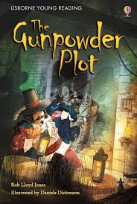

**History & Geography**

In history this term we will be learning:

-Key facts about the Gunpowder Plot

-How Guy Fawkes has impacted our lives.

In Geography we will be learning:

-The countries and capital cities in the United Kingdom.

-Draw maps

-Follow a route on a map using North, South, East and West.

**Art**

In Art we will be painting bonfire night pictures and learning to:

-Make links between Bonfire Night and Art

-Say how artists/craftmakers use colour, pattern and shape

- Mix paint to explore colours and create different shades of a colour

**Computing**

In Computing we will be learning to:

-Find and retrieve information from a website

-Use texts, pictures and animations to create content.

-Create, edit and format text

-Coding

**Music** Exploring sound, choosing instruments and listening to sounds all around us.

**Global Citizenship and RE**

Can I recognise similarities and differences between people? Can I understand the needs to protect the rights of others? Can I understand reasons for personal disagreement? Can I understand some ways of avoiding, managing and solving conflict?

In RE we are looking at whether it is possible to be kind to everyone, focussing on the life of Jesus.

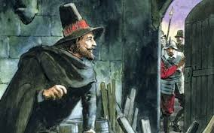

**Reading:**

Please read **every night** to an adult. This can be your school RWI book, an online Bug Club book or your reading for pleasure book. Please get an adult to comment and sign your planner please.

Every Monday we will count the number of reads for the week and have our reading treat for those that have read 5+ times.

**Mathletics & Times Table Rockstars**

Children will have access to Mathletics and are able to earn bronze, silver & gold certificates.

Times Table Rockstars is a fun and challenging app designed to help children master their tables.

**Home Learning**

**Physical Education**

Please come to school **DRESSED IN PE KIT** on days when you have PE/Scotty’s Heroes please. Children will not be getting changed in school, therefore you **do not need** school uniform on those days, thank you.

**Mighty Ducks have PE on a Thursday**

**Kingfishers have PE on a Mondays.**

Please remember for PE kit you will need:

* trainers or pumps, a plain white t shirt, black / navy shorts.
* If the weather is cold, you are able to wear black navy tracksuit bottoms and a black / navy jumper / tracksuit top.