Where does our food come from?

On Friday 23rd February, we will be going to see WONKA at Vue Cinema.

The children will learn about Willy Wonka and his amazing Chocolate factory!

During this term, we will focus on using adjectives, expanded noun phrases and suffixes.

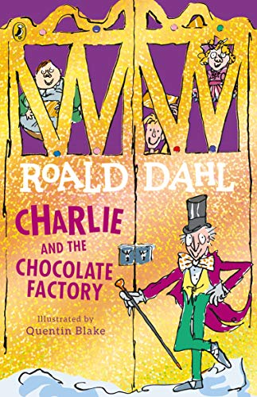

Spring Term 2024
Year 2 Kingfishers and Ducks

In Maths we will be learning:

-Multiplication and Division facts for our 2,3,5 and 10 times tables.
-Counting money in pounds and pence
-Finding fractions of numbers, amounts and lengths
-Recognising and describing 2d and 3d shapes
-Addition and subtraction of numbers within 100.

Mathematics
Novel Study
Year 2 Autumn term 2020
Foundation Subjects

Science
-Do I know where food comes from? – Looking at how chocolate is produced
-Describe the importance of exercise, eating the right amount of foods and hygiene by writing a non-chronological report for Augustus Gloop.
-Prepare healthy dishes.

Geography
-The Seven continents, the UK and the surrounding seas
-Follow a map of the local area
-Draw a map of the local area.
-Human and physical features in Doncaster
-Observational skills
-Collect and record evidence
-Compare and contrast a small area of the United Kingdom with a small area in a non-European country

Design and Technology
-To design and make a healthy snack.

Global Citizenship and RE

Judaism
How important is it for Jewish people to do what God asks them to do?

Christianity
How important is it to Christians that Jesus came back to life after His crucifixion?
Global Citizenship
Can I recognise similarities and differences between people? Can I understand the needs to protect the rights of others?
Can I understand reasons for personal disagreement?
Can I understand some ways of avoiding, managing and solving conflict?

Please come to school DRESSED IN PE KIT on days when you have PE/Scotty’s Heroes please. Children will not be getting changed in school therefore you do not need school uniform on those days, thank you.
Kingfishers have PE on a Tuesday and Ducks have PE on a Thursday.
Please remember for PE kit you will need:
- trainers or pumps, a plain white t shirt, black / navy shorts.
- If the weather is cold, you are able to wear black navy tracksuit bottoms and a black / navy jumper / tracksuit top.

Physical Education
Home Learning

Reading:
Please read every night to an adult. This can be your school reading for pleasure book, a book you have accessed on Bug Club or your Read Write Inc book. Please get an adult to comment and sign your planner please. Reading records will be checked every Monday.

Numbots, Mathletics and Times Table Rockstars
Children have access to these apps and certificates are handed out each week.

.

