Communication and Language |  | Personal, Social and Emotional Development |  | Physical Development
This half term will about different celebrations. We will talk about sounds we might hear around bonfire night. We will play lots of listening games with musical instruments and other objects. Some other activities will include:  - Listening to stories and talking about the different characters and how they might feel.  - Learn to ask simple questions during show and share. |  | We will continue to build on the relationships we have formed and start to form new ones with other children. Children will become more independent in self-care activities such as washing their hands and putting on their coats. Other activities will include:  - Trying some new foods during snack time. |  | We will spend time exploring the outside area to encourage children to practice and refine gross motors skills. Other activities will include:  - Using streamers to create firework movement.  - Dance to different music and explore different ways of moving.  - Begin to use scissors to make our Christmas list using catalogues.
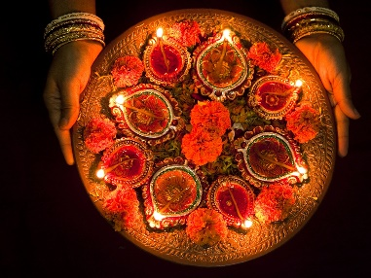

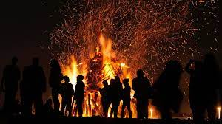
Robins
Celebrations
Literacy | Mathematics |  | Understanding the World |  | Expressive Arts and Design
Each morning children look for their name card to self-register, this will help children to recognise their name. Children will also be encouraged to have a go at writing their name either by tracing or copying the letters in their name.  Other activities will include:  - Writing our Christmas lists.  - Creating our own Mehndi patterns when learning about Diwali.  - We will continue to do daily phonics lessons to build children’s awareness of letters and the sounds they make. | Each morning we will sing our days of the week song to help children understand the concept of time. We will also use ‘Ten Town’ to become masters of the numbers 0-10. Other activities will include:  - Extending a colour patterns.  - Finding one more/less than the numbers we have learnt about in ten town time.  - Using numicon to find different ways of making numbers. |  | We will spend time talking about different celebrations and how our families celebrate special times.  Other activities will include:  - Talk about Diwali and why it is an important festival.  - Celebrate what makes us special during anti bullying week. |  | Children will have the opportunity to develop their creative and imaginative skills using a wide variety of art and craft materials. Other activities will include:  - Painting poppies to remember the soldiers who fought for us.  - Using clay to make our own Diva lamps.  - Learning songs to celebrate the first Christmas.

